Best Worst Writing Lessons

Objective: To help students recognize common writing patterns that may hinder the enjoyment or comprehension of the reader.
To do this students will need to:
- understand that writing requires consideration for the audience
- recognize the various CWPs (Common Writing Patterns)
- ‘try out’ the various CWP styles

Rationale: There is a wide body of research on the power of using examples and non-examples to teach concepts and skills. In writing, we often teach examples of strong, effective writing, but rarely provide students with examples of traits that are not effective and make the writing confusing or uninteresting for the reader. This lesson will provide students with an awareness of writing patterns that are common for elementary students as “non-examples” for what we want to see.

Rather than only addressing these patterns after they appear in student writing (during conferences or with grades), we can introduce them to some common ‘pitfalls’ that writers encounter to help them self-monitor, self-revise, and self-regulate their writing. By immersing them in the composition of these ‘moves’ we can increase their familiarity with them and this in turn can foster greater awareness of avoiding or self-monitoring these instances.

I CANs
I can recognize Common Writing Patterns (CWPs) in a piece of writing.
I can write examples of CWPs so that I am more aware of them in writing.

Lesson
“Today we are going to talk about some common writing patterns that novice writers often use that can sometimes make the reading difficult, confusing or uninteresting for other readers. Often we aren’t even aware we are using one or more of these patterns, so today we are going to spend some ‘studying’ them so we can be more aware of them. Researchers have found that people learn best when they are given examples of what to do and ‘non-examples’ of what to avoid. We often share with you examples of good writing to encourage you to try them out. Today we are going to do something to share non-examples.
First I will share with you 9 patterns I frequently see in student writing. These aren’t the only patterns, you might recognize others, but we’ll start with these:”

Common Writing Patterns

PATTERN | FICTION | NONFICTION
1. ALL ABOUTS | In FICTION they tend to be listy, almost a schedule or agenda of an event. “Watermelon” ideas instead of “seed” ideas.  NO Problem/Resolution, mostly description | In NONFICTION topics are very broad and not deeply explored. Often literally titled “ All About…” They tend  to list some facts but sentences  may not connect or expand  Ideas.
2. FIZZLERS | These pieces may start out with an engaging lead or a strong start and literally fizzle. May have a beginning and middle but ends abruptly. | In NONFICTION piece starts strong but looks like writer lost interest or stamina.
3. SHIFTERS | In FICTION These pieces may change setting or transition in time abruptly. It can leave the reader wondering what happened in between ‘scenes’. The pieces may contain a lot of thens or ands for transition words or may contain no transition words or phrases. Do NOT write with the end in mind & cannot explain the heart of their story. | In NONFICTION pieces the elements do not connect to one another. They need ways to connect ideas and topics more smoothly. They often lack a nonfiction organizational structure. and/or transition and signal words. Main Idea may be hard to find. Often very similar to ALL ABOUTS style.
4.  GENERICS | In FICTION these pieces have characters w little detail or description, no backstory, no reaction to events. The setting is often not mentioned or not described well. We cannot envision the intended ‘world’ of the writer. No evidence of engaging lead (hook), “exploded moments” or voice. | In NONFICTION they do not use domain specific vocabulary and speak in generalities about their subject. May contain “dry” and somewhat uninteresting facts. They may be true, but they do not engage the reader.  (closely related to ALL ABOUTS)
5.  TALKERS | In FICTION these pieces are almost exclusive or overbearing with dialogue. It is almost a transcript of a conversation. | In NONFICTION pieces the author ‘talks’ about their opinions rather than facts. They may write sentences that could easily have the words “I think…” inserted at the beginning. (ex. Penguins are the coolest bird.)
6.  HUSHERS | In FICTION these pieces contain no dialogue or no ‘thoughtshots’ (a look at what a character is thinking or feeling). Reaction to events is usually tell, not show (He was scared. rather than “What was that?” he screamed.) Often closely tied to VULCAN style | In NONFICTION they may not contain any quotes from experts or from texts that they cite.
7.  SLANGERS | The writer uses slang or non- standard grammar/vocabulary. They may not notice how ‘non-standard’ it sounds to others because it represents the way they speak. | The writer uses slang or non- standard grammar/vocabulary. They may not notice how ‘non-standard’ it sounds to others because it represents the way they speak.

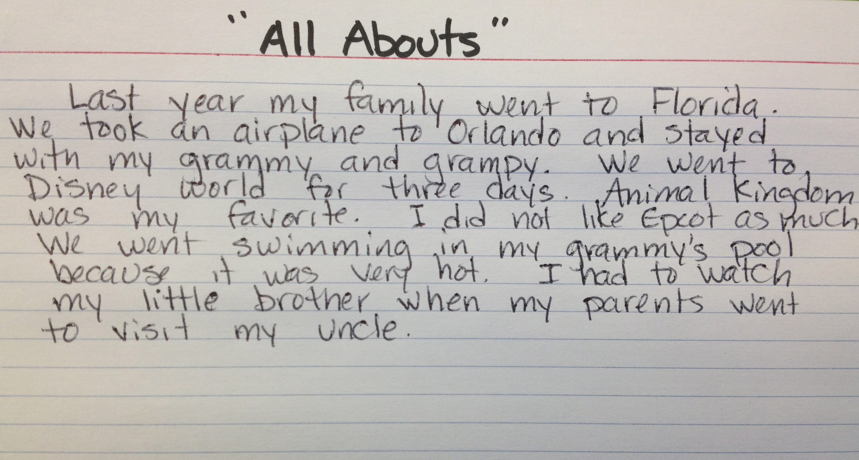
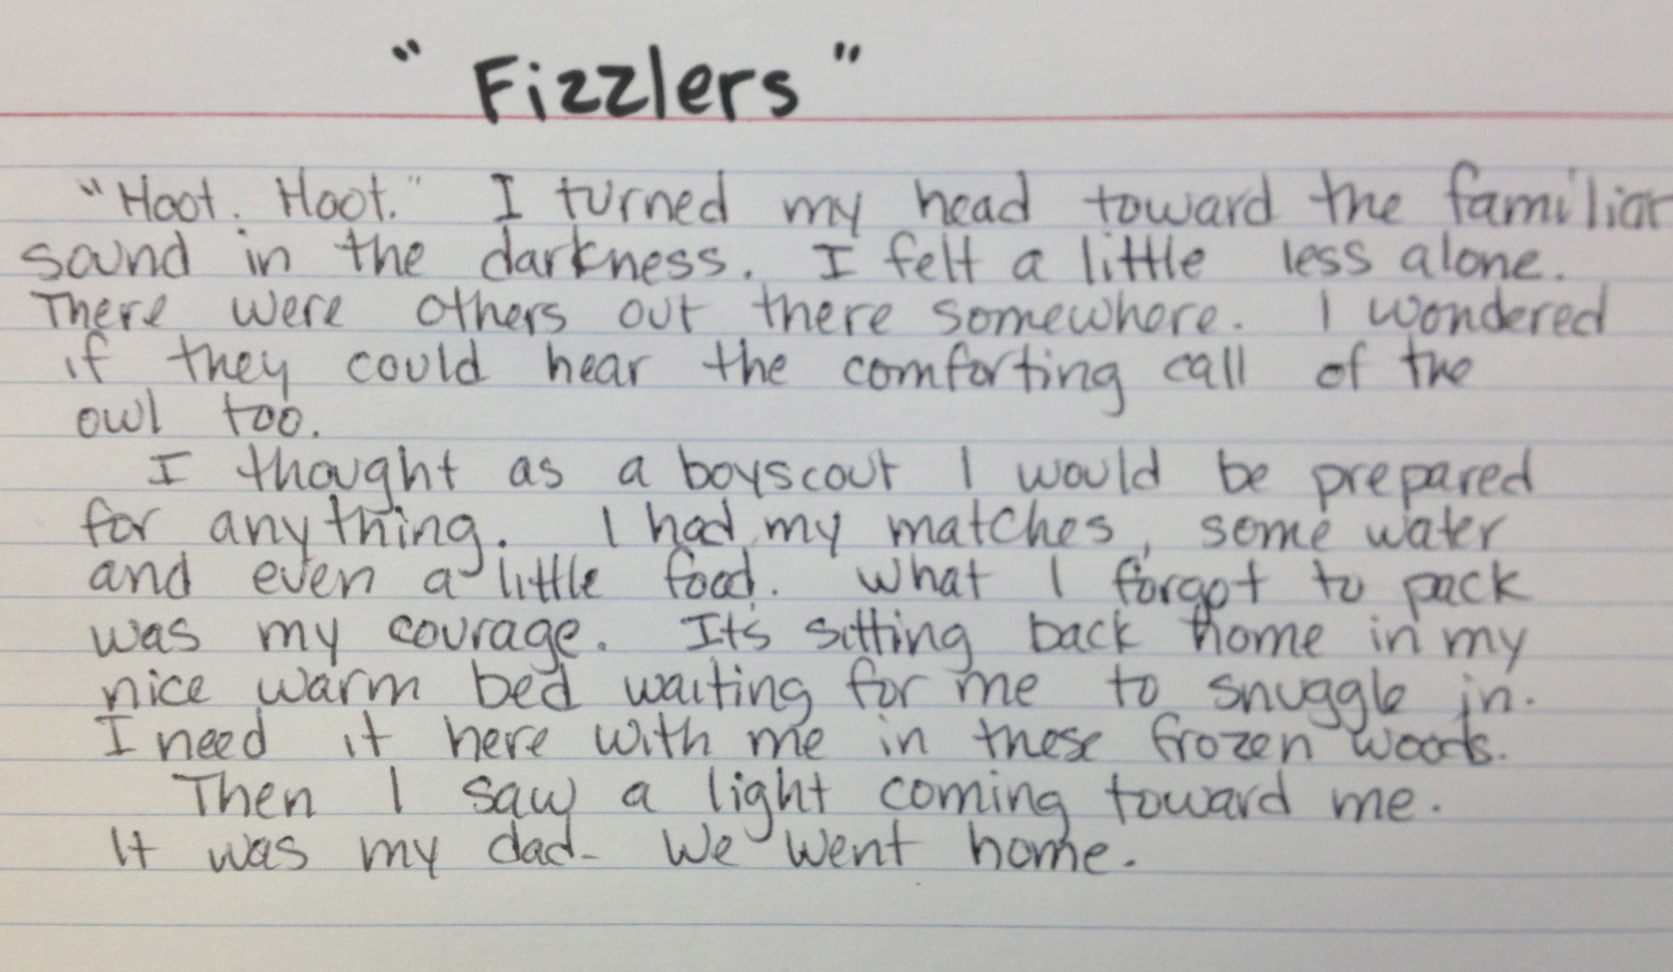
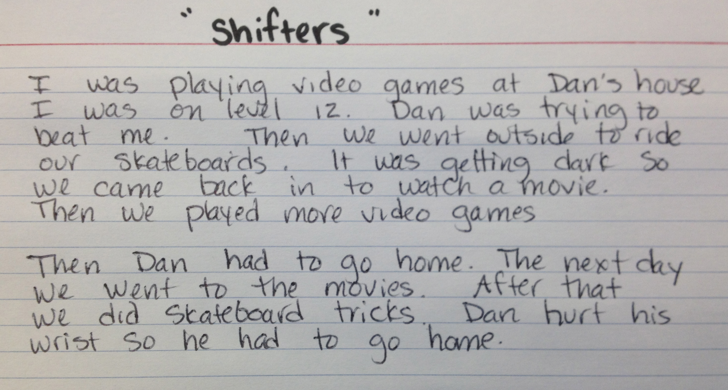
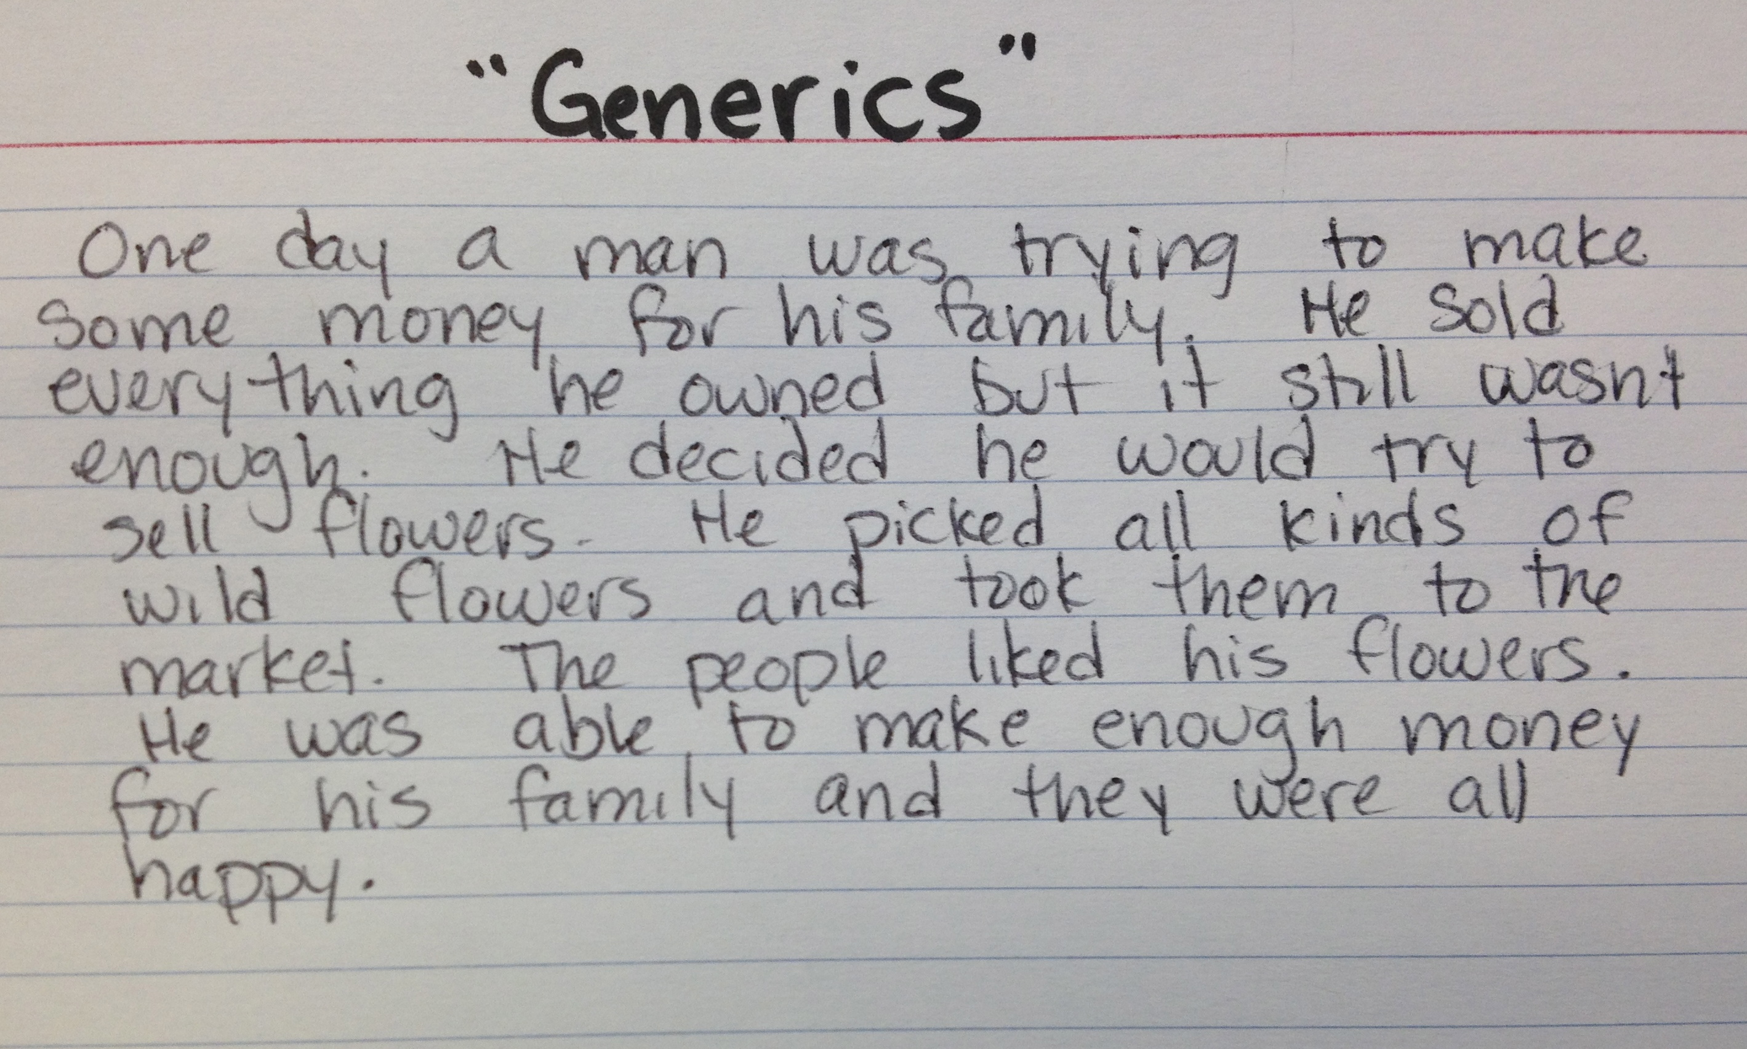
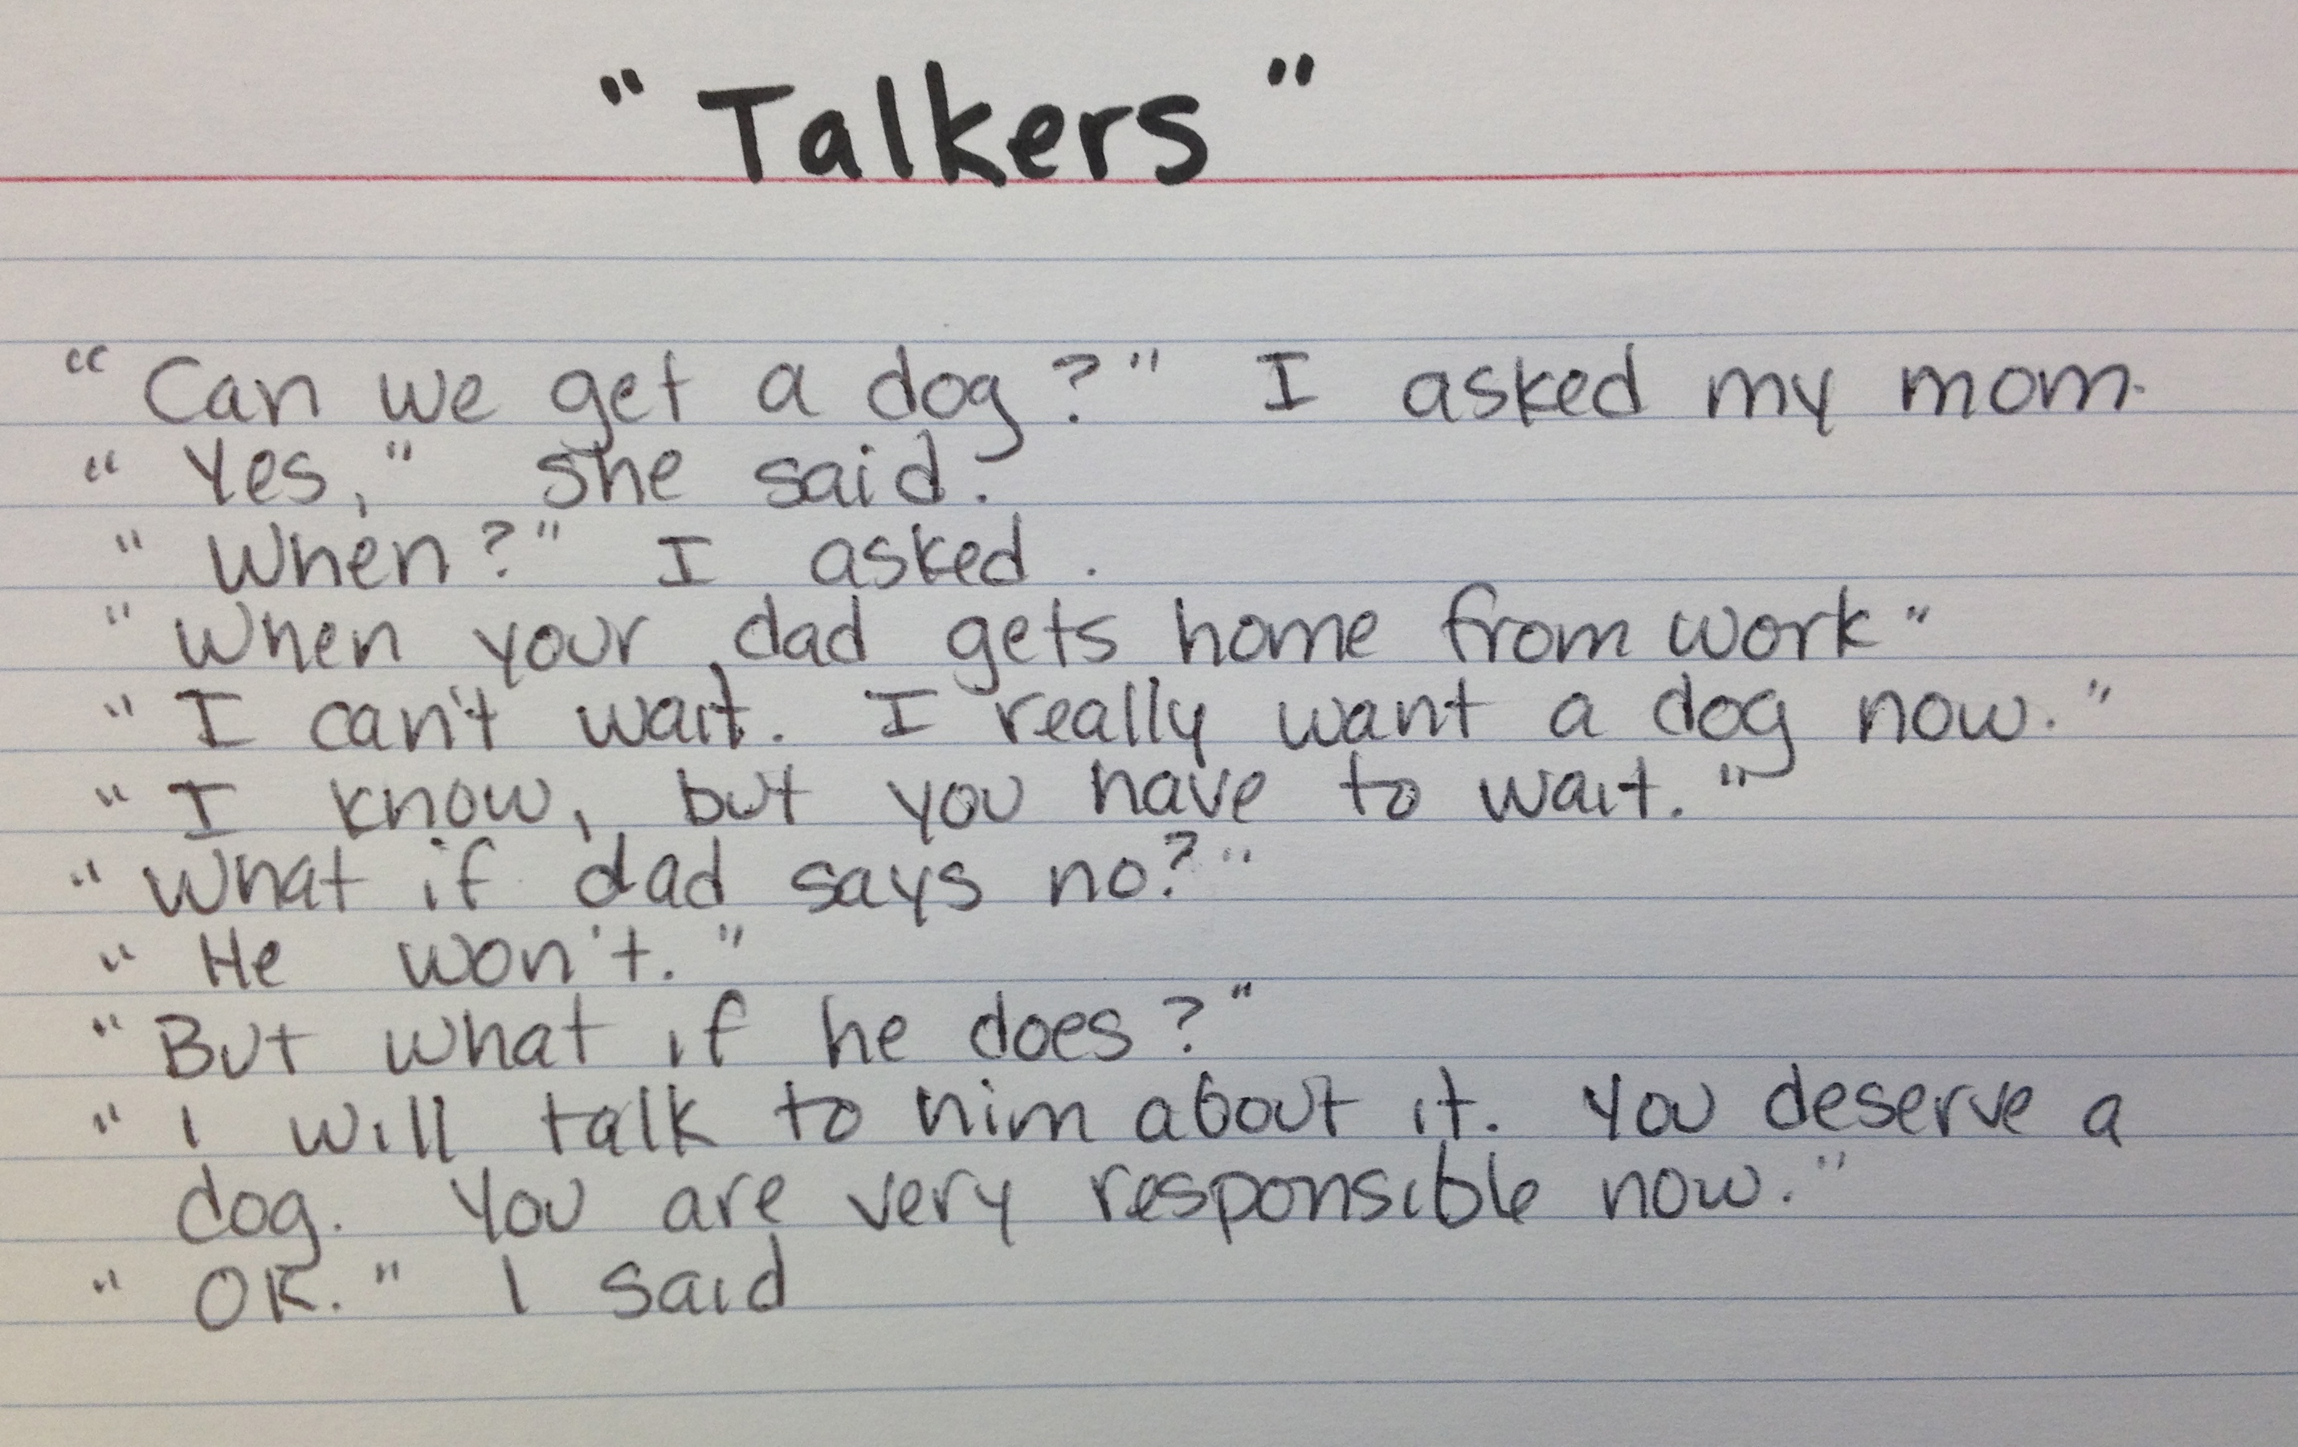
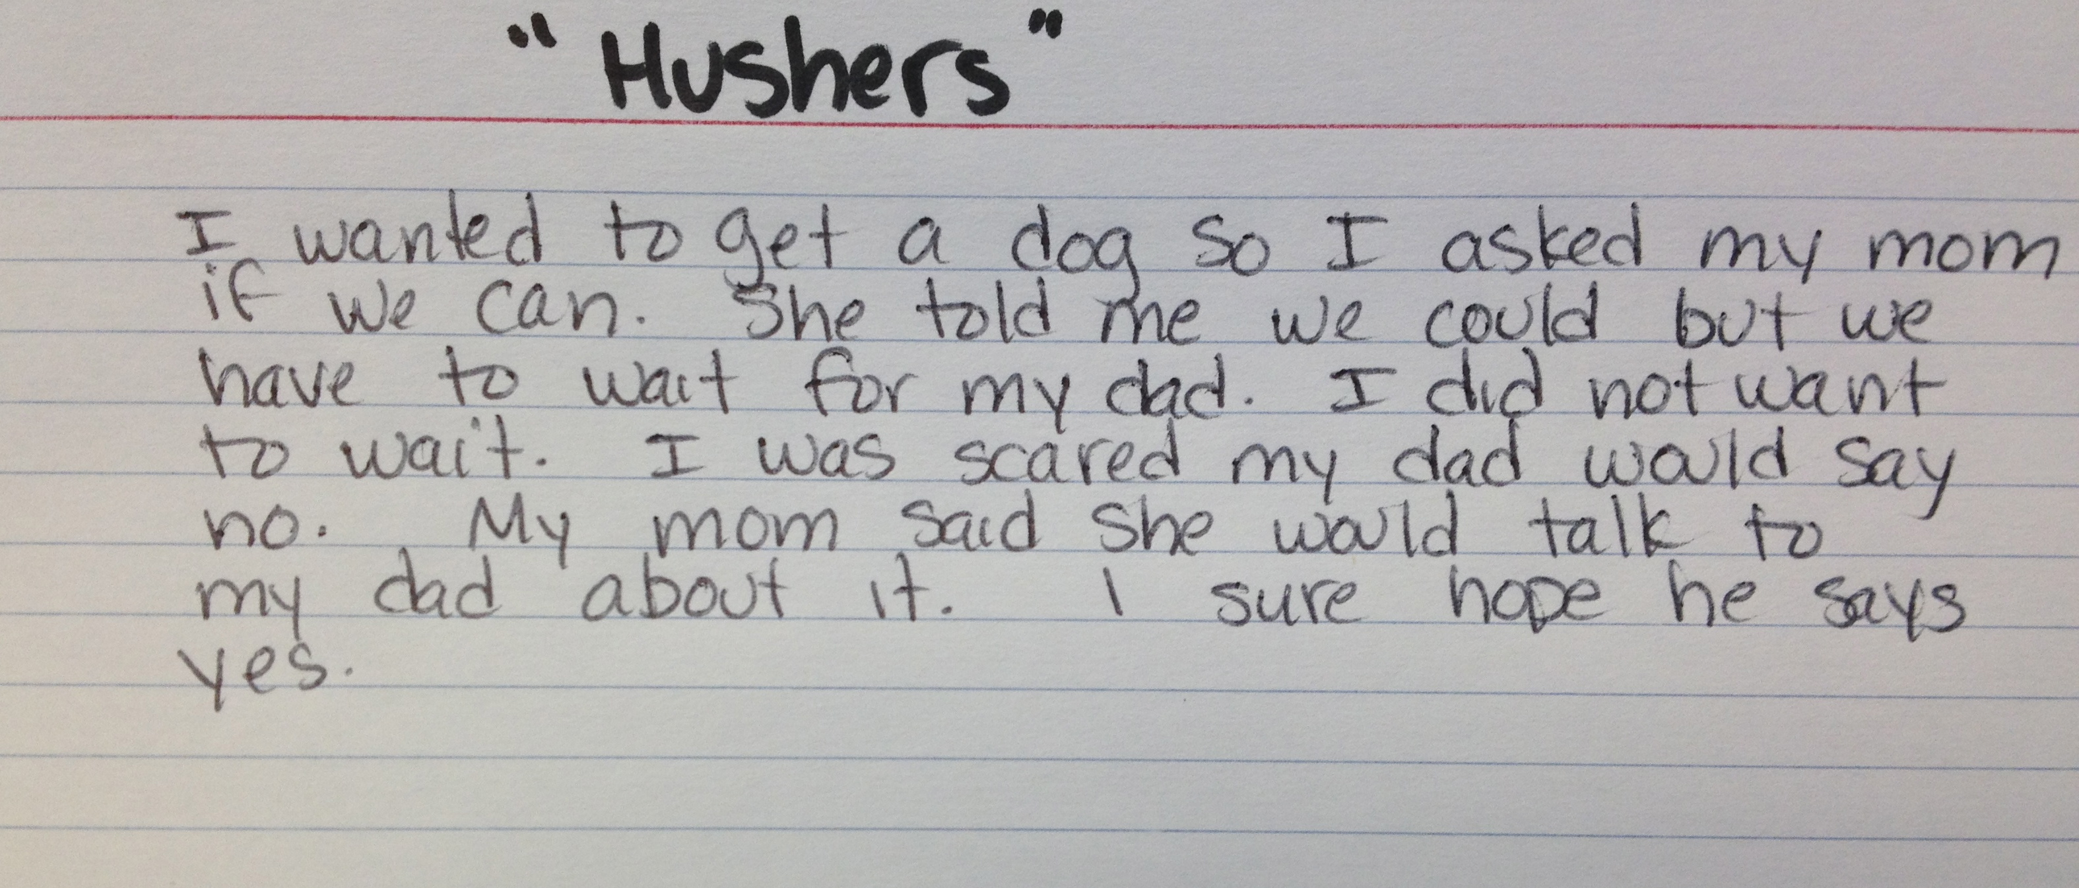
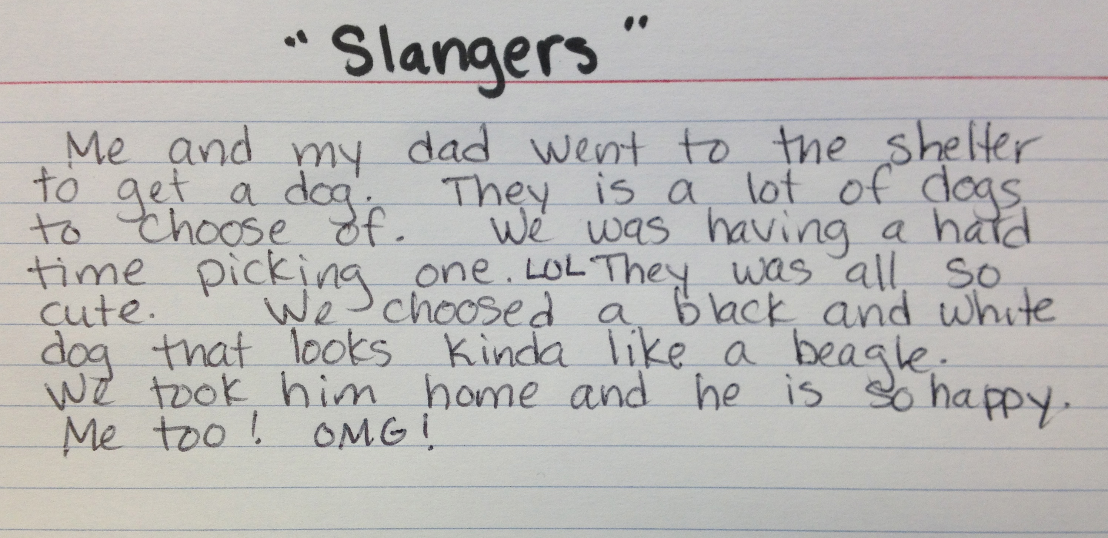

Guided Practice 15-20 min
Option 1: You are going to draw a number (out a can/box/jar/bag) and that will tell you which CWP you are going to try out today. You do not need to write a complete piece, just a sample of how your writing might look if you fell into one of these patterns.

Option 2: You are going to work with a partner today to try out one of these CWPs. You do not need to write a complete piece, just a sample of how your writing might look if you feel into one of these patterns. Take turns discussing and sharing the pen as you draft a “mentor text” of your assigned CWP.
(Teacher can pre-assign student partners and the type of CWP they will work on)

If students finish ‘early’ they should choose a second CWP and try it out.
Teacher can circulate about the room answering questions, supporting students and listening for comments they make that could provide insight into what they are noticing and thinking as they build schema around these CWPs.

Share: Provide time for each student or partner to share their pieces. They could either read them first and ask others to recognize the pattern they used, or announce the pattern and have students ‘tune in’ to listen for those characteristics.
Students should also be able to share some of their thinking that went on as they composed pieces.

Anchor Charts:
Use student exemplars for classroom anchor charts for BEWARE of CWPs.

Save student writing samples for “mentor texts” for future lessons.

BEST WORST WRITING CONTEST!

Students are invited to submit entries for each of the categories that exemplifies a strong example of the Common Writing Patterns (CWPs)
Entries will be accepted all spring and “winners” will be chosen in June. The winners will be included in Anchor Charts and Mentor Text collections used to raise awareness of CWPs in writing.

Teachers can determine where/when students can work on these submissions. (in class, extra time, homework, etc)
Each entry must be accompanied with the Entry Coversheet.

Best Worst Writing Contest

Student_________________

Grade________

School__________________

This is an example of ______________________ CWP
(Common Writing Pattern)

All Abouts | Fizzlers | Shifters | Generics
Talkers | Hushers | Slangers

Please attach this cover sheet to each entry.

To Be Sent Home for SELECTED ENTRIES ONLY

Parent Permission for use of Student Work

We are looking for student work to be used as anchor papers for Common Writing Patterns (CWPs) that we want students to be aware of that can make it confusing or uninteresting for a reader. We are using the research behind “non-examples” to solidify concepts and understandings to shape learning about writing. By trying out these patterns with intention, it will raise their awareness of the characteristics to help them monitor and avoid these in their daily writing. These samples could be used for a variety of projects. The children’s names will not be used.

Your child’s piece was selected as one of the BEST WORST WRITING samples.
He or she was able to analyze the common writing pattern and create an original piece of writing that would demonstrate that pattern for others. We would like to use it for professional development projects such as lesson plans, anchor charts, books, articles, presentations, etc. Your child’s identity will remain anonymous.

_____Yes, Paula Bourque (Literacy Coach Augusta School Dept) has my permission to use my child’s work for professional projects. I understand that these projects will help teachers learn more about literacy development and best practices in the teaching of writing.
I understand that I can revoke this consent in writing at any time.

___________________________________________ ______________________
Child’s Name Date

Parent or Legal Guardian’s Signature

If/Then

When students become more proficient at reflecting on their own writing and analyzing any patterns they may observe, they need to know what to do next. Helping them to consider next steps may be best scaffolded with an “If/Then” format. If I notice a particular pattern emerging in my writing, Then I could consider trying this…

All Abouts

If... | Then...
My writing seems listy, I use ‘then’ a lot | - I may need to add more details before moving on to next idea.  - I may need to vary my transitions  - I may need to reorganize my ideas so they connect better
My topic is very broad | - I may need to narrow it to something more specific  - I may need to organize into subtopics

Shifters

If... | Then...
I have more than one setting | - I need to describe each setting to the reader  - I need to transition the characters to the new setting logically  - Consider how the setting affects the plot
My story takes place over time... | - I need to consider how much time (a day, a week, years…)  - I need to show the passage of time with transitions and descriptions  - I need to think about the chronology  - I don’t leave gaps in the story  - I start as close to the end of the story as I can  - I decide if I will have flashbacks or flash forwards
I have more than one character | - I need to consider how I will introduce them  - I will need show a relationship between them
I don’t know how my story will end | - I need to think about what the problem is and how it will be resolved  - I need to map out my story so that it reaches that conclusion  - I need to think about how my characters will change or grow  - I need to think about any lessons to be learned
I have a lot of “thens” or “ands” | - I need to think about more precise transition words or phrases

