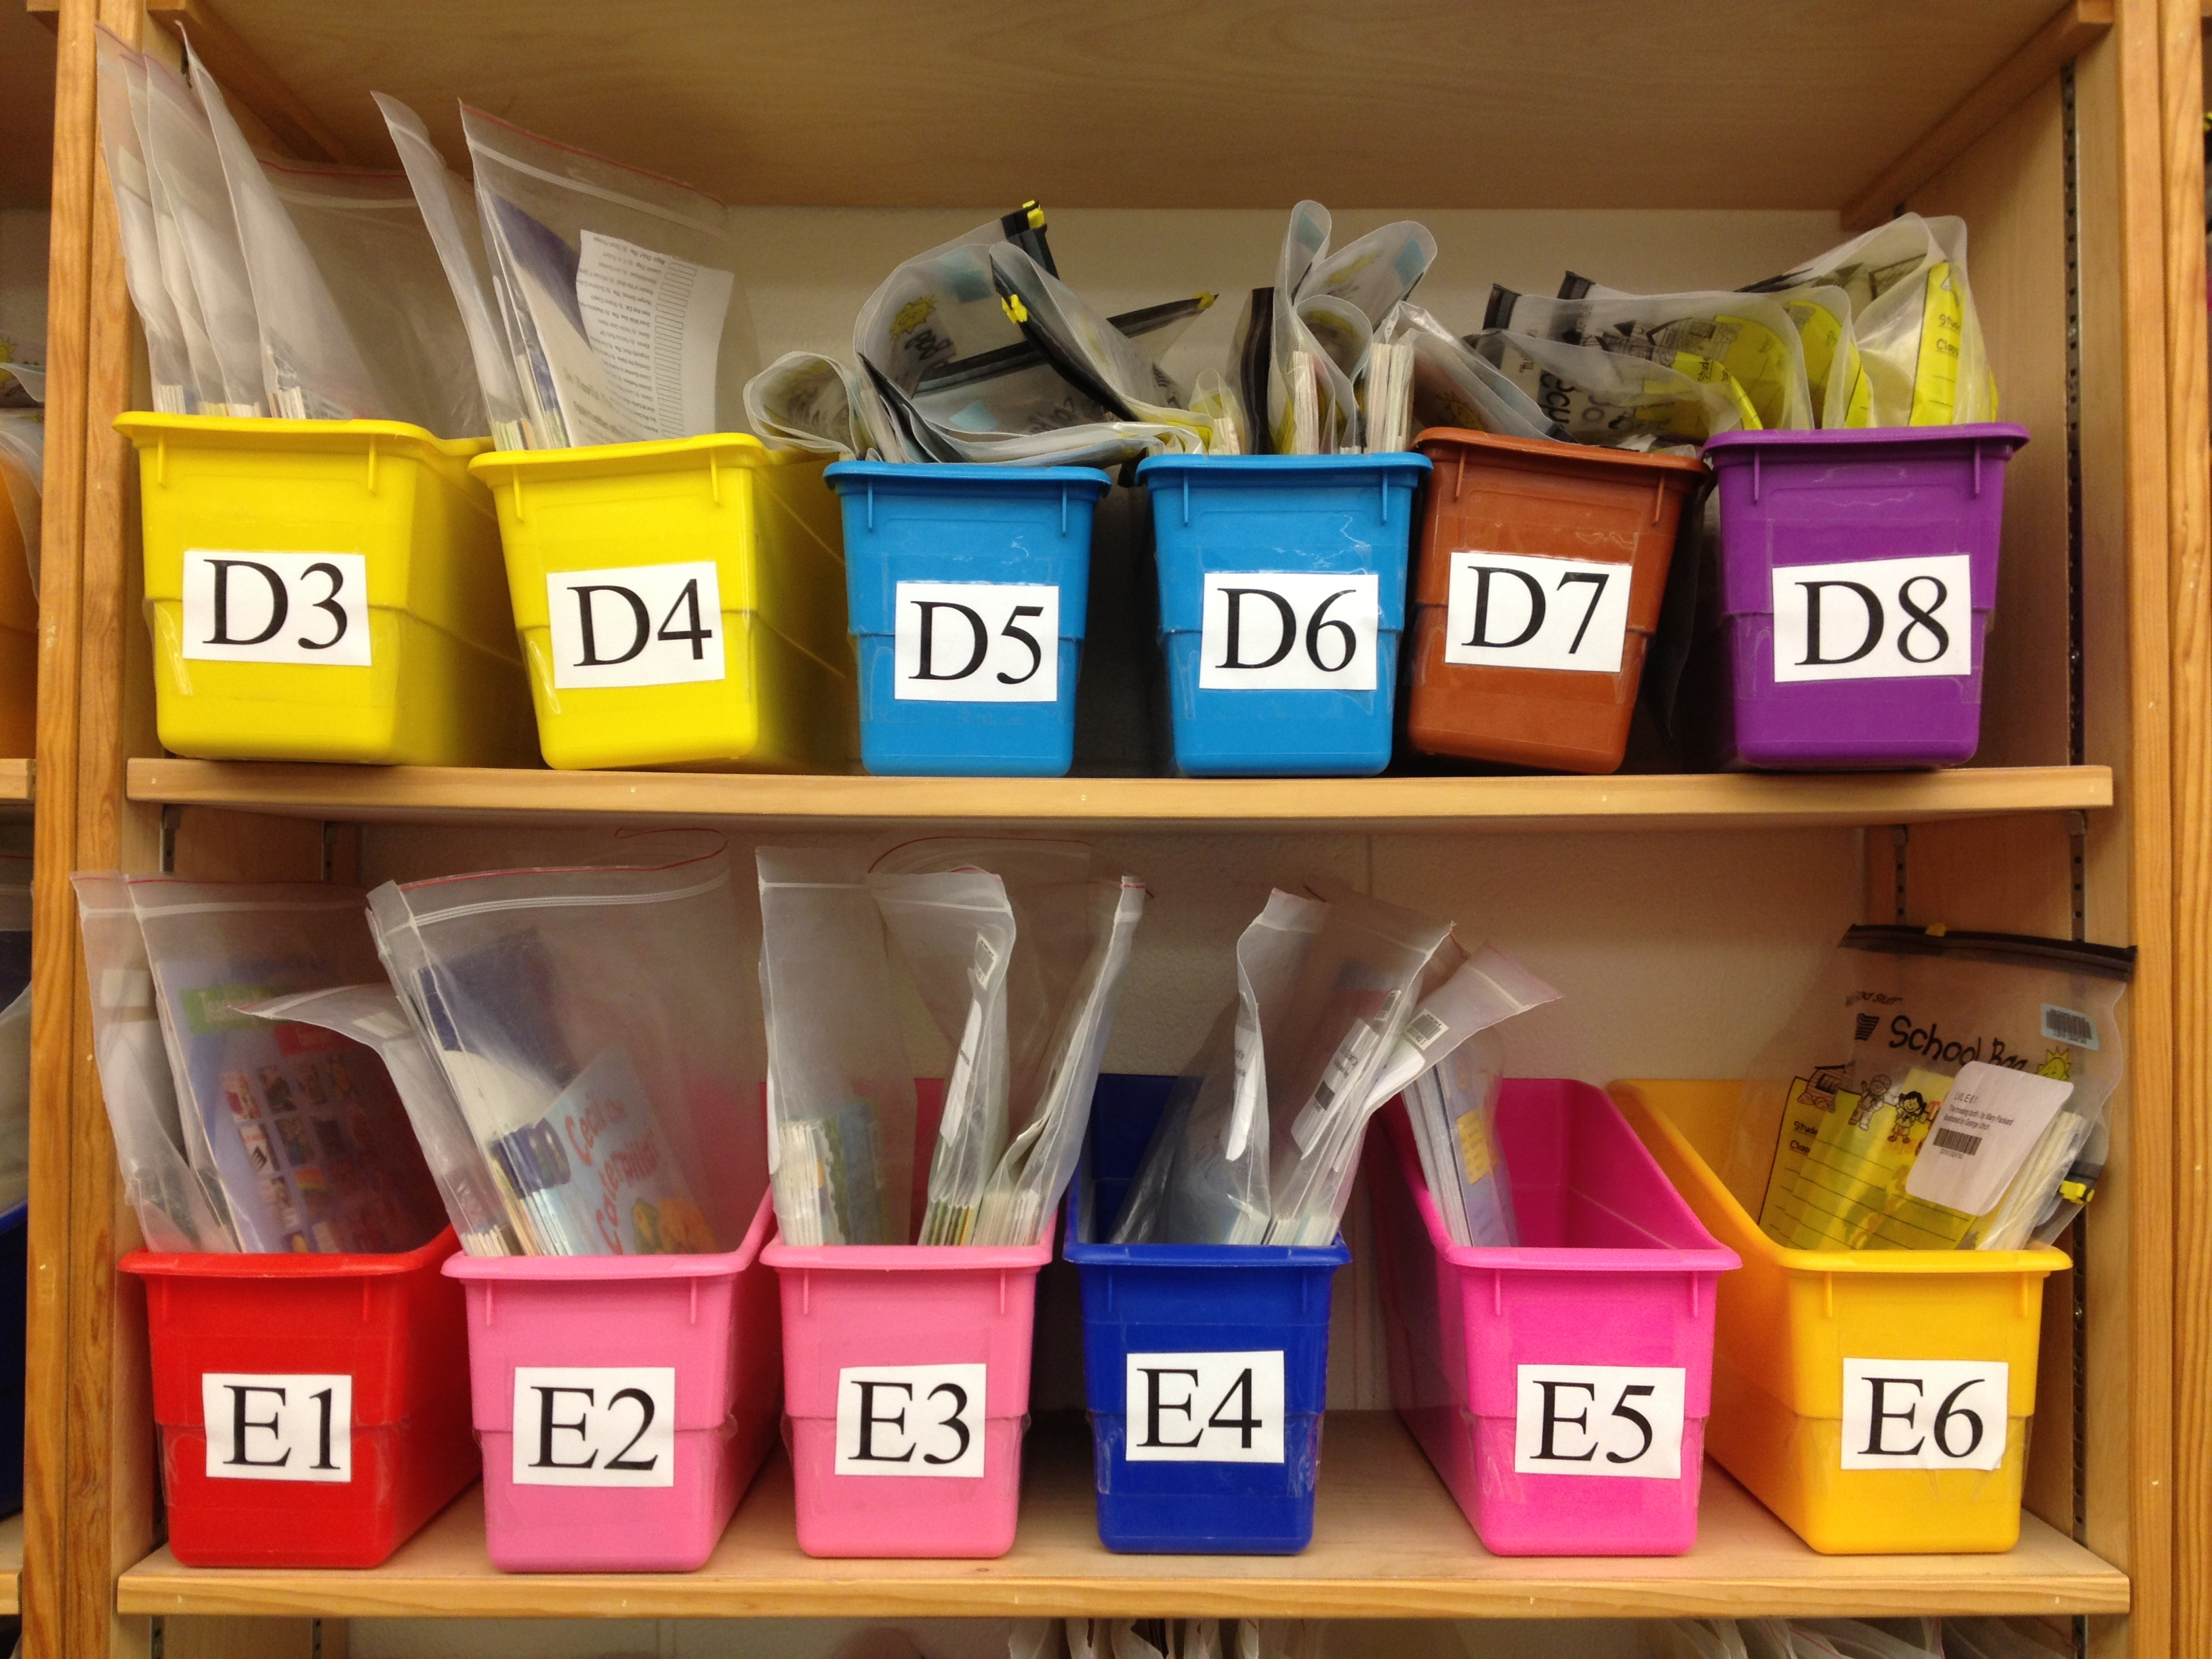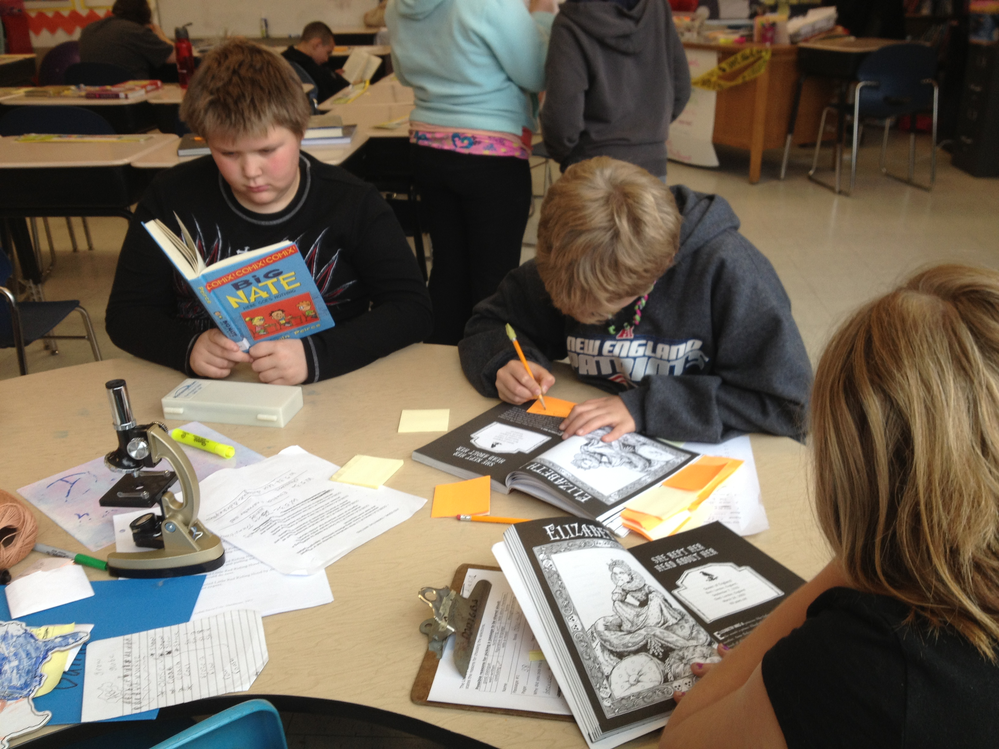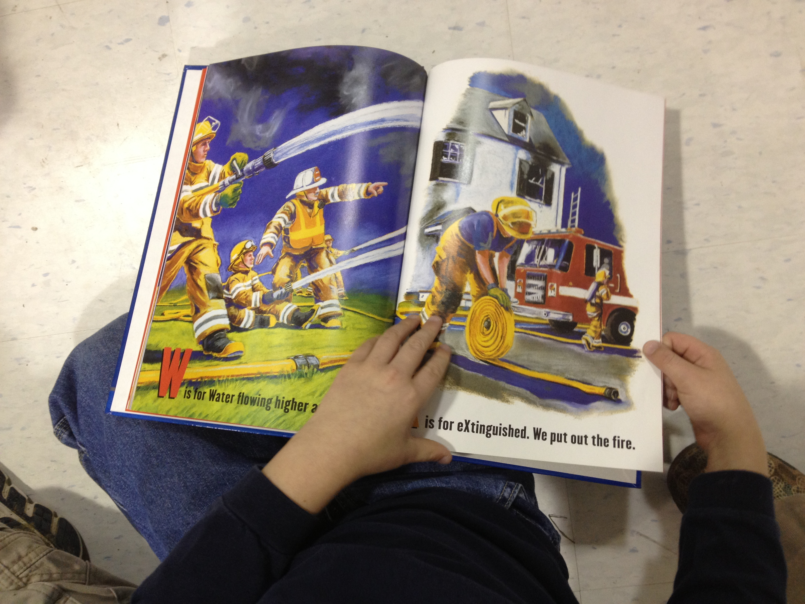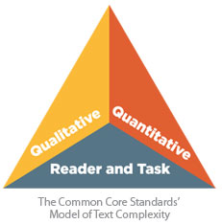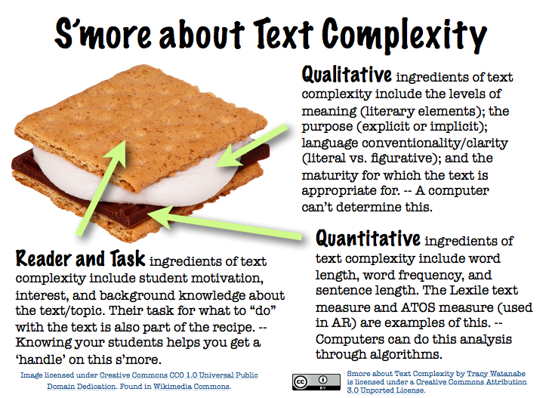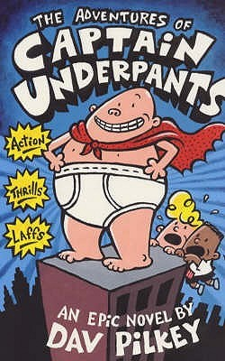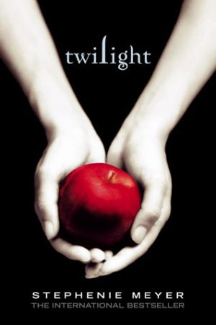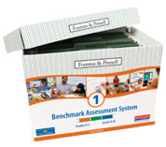

**Paula Bourque 2017**

*“One of the key requirements of the Common Core State Standards for Reading is that all students must be able to comprehend texts of steadily increasing complexity as they progress through school.” CCSS Appendix A*

So what does that mean for your child? Many of us are becoming familiar with the idea that books are ‘leveled’. Your child may report to you that he/she is reading a Level D or a Level A, B or C book. What they may not convey is the depth of comprehension they are expected to demonstrate on those varying levels of text. They only notice the “**level**” and often want to race to that next level. Sometimes parents are frustrated that their child hasn’t moved through enough levels or hasn’t moved more quickly. Before you become concerned we’d like you to consider:

The level is only one piece of text complexity. It is the **quantitative** element; meaning it can be mathematically analyzed by word length, sentence length, etc. Lexile levels, guided reading or F&P levels, are examples of quantitative measures.

**Qualitative** measures look at the style of writing, the familiarity of language & the type of structure that cannot be measured by formulas or computers. They require an attentive human reader.

**Reader and Task** considerations refers to *reader* motivation, attention span, memory, prior knowledge, experience, use of comprehension strategies as well as the particular *task*  assigned for the reading and the readers’ purpose and engagement with the text.

Your child may not be moving up in level (quantitative) as quickly as you might assume, because your child’s teacher may be expanding their experiences with qualitative measures or types of tasks with which they need to become stronger.

Students can often decode texts at a much higher level than they can comprehend deeply. Your child may be decoding books several grade levels above their rank, but may not be comprehending with mature strategies or depth expected at those higher grades.

Before you put too much emphasis on the “level”, talk with your child’s teacher about how your child is building competence with expected text complexity and developing higher order thinking skills with a variety of texts. Lifelong readers won’t need to race through levels!

**Reading is more than decoding!**

### Why levels don’t give us the complete picture

### of your child as a reader.

# Understanding Reading Levels



*Lexile Level 720

##### **Levels are for BOOKS**

**Not CHILDREN!**

##### Schools often use assessments such as Fountas & Pinnell Benchmark Assessment, a DRA, or others to give a snapshot of acquired reading strategies and they often provide approximate level of text that would be supportive in a child’s literacy growth. Your child is not a level or a Lexile! Most of the time we want students to choose books that interest and appeal to them and that can’t be leveled. Motivation and excitement can support students through books we might consider a difficult level for them. There will be other times when your child’s teacher will match your child with an appropriate level text on which to practice reading decoding and comprehension, but readers should never be restricted in self-selection by a range of levels. Also, the level of the text does not represent the grade level expectation for reader and task. 4th graders would be expected to exhibit much deeper and much more complex thinking on a Level S text than a 2nd grader would. Pushing students through levels does not make them deepen their comprehension, often “easier” books allow students to think more deeply and analyze more effectively because they aren’t overly focused on decoding. Encouraging a wide range of genres, topics, and can be more

##### Important than focusing on levels.

**DON’T ABANDON PICTURE BOOKS!**

Picture books often deal with topics that are relevant and age appropriate. They deal with children’s fears, they make sense of our complex world in developmentally appropriate ways, and they teach a wide variety of topics with focus and clarity. Reading chapter books requires a much longer time commitment than reading picture books. In the time a student reads one chapter book, they could have read multiple picture books, exposing them to a greater variety of ideas, concepts, perspectives, complex vocabulary, genres and information. Children have a greater wealth of knowledge and understanding about their world when they have broader exposure to information about it. Treating picture books as ‘baby books’ discourages students from this valuable format. We want to create well-rounded readers and picture books can truly help!

**Reader’s Purpose**

**and Book Choice**

When our purpose for reading is entertainment or pleasure we often choose books that are easy and enjoyable. Our children are the same. They do not always need to be ‘pushed’ into more complex books if it doesn’t meet their purpose. Picture books, graphic novels, wordless books, ‘easy books’ should not be discouraged or labeled “Too Easy” for pleasure reading. Your child’s teacher will match just right books to his/her instructional time when the purpose is *to grow as a reader*. A level will help with that, and the lessons will support them. So allow them plenty of fun opportunities with books that interest **them** without worrying about a level. We want to create a LOVE for reading so that they will become lifelong readers and not

“*Level Z readers!* **Reading for pleasure is one of the most important purposes for building lifelong reading!!**

These books are all considered 3rd or 4th grade reading level*. That is the quantitative measure. As you can see, that doesn’t give us the whole picture!

**LEVELS CAN BE MISLEADING**